**Registration Form**



This is not a juried exhibition. This information is only for us   
to work with you better through the process

|  |  |
| --- | --- |
| Name |  |
| Address |  |
| Phone |  |
| Email |  |
| Art Background  You can be brief i.e. painter, 3-d artist. You don’t have to be a professional artist. Everyone is welcome to participate. It helps us assist you if we know what your background is. |  |
| Have you been to the Farley Center before? |  |

Can you commit to:

**□ Sat. May 6** 1-3 pm - Come to one organizational meeting at the Farley Center

**□ by May 20** Commit to participating and submit your registration form

**□ by June 20** Choose a site in the Natural Path Sanctuary.

**□ by Aug. 1** Let us know the title and 1-2 lines about your piece.

**□ by Aug 15** Have your piece complete (you can work all through summer)

**□ Sept. 23** Be present at the Artist Talk/Reception and be prepared to talk  
 a little about your piece as we lead a walk-about viewing the art.

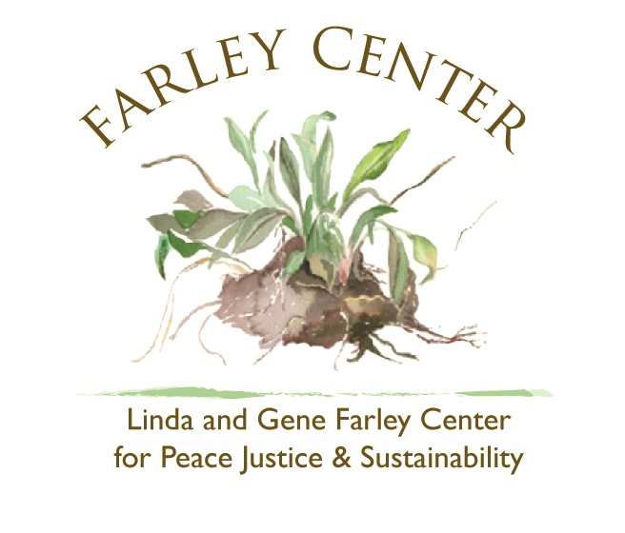

**Email the completed form to:  
Caroline Tu Farley, Program Director,** [**programs@farleycenter.org**](mailto:programs@farleycenter.org) **or mail to 2299 Spring Rose Rd, Verona, WI 53593**